Title: | Door Control Module  SW Component CANServices

History
Issue status  (Index) | Maturity/Date  (draft/invalid/valid)  (dd-mmm-yyyy) | Author  Department | Check/Release  Department | Description
1.0 | Draft  31-Jan-21 | Rubén Cocoletzi | - | Initial versión

Table of Contents
1 Purpose 3
2 Definitions and abbreviations 3
3 Realization constraints and targets 3
4 SW Conceptual design 4
5 SW Component internal breakdown 5
5.1 Functional Decomposition 5
5.2 Function void CANServices_ReceivedMessages (struct CANFrame) 6
5.3 Function void CANServices_PeriodicTransmition (void) 7
5.4 Function void CANServices_Init (void) 8
5.5 Function void GetRearWindowLockSignal (RearWindowLockSignal* RearWindowLock) 8
5.6 Function void WriteRearWindowLockSignal (RearWindowLockSignal RearWindowLock) 8
5.7 Function void GetWindowControlSignal (WindowControlSignal* WindowControl) 9
5.8 Function void WriteWindowControlSignal (WindowControlSignal WindowControl) 9
5.9 Function void GetWindowOpSignal (WindowOpSignal* WindowOp) 9
5.10 Function void WriteWindowOpSignal (WindowOpSignal WindowOp) 9
5.11 Function void GetWindowPosSignal (WindowPosSignal* WindowPos) 10
5.12 Function void WriteWindowPosSignal (WindowPosSignal WindowPos) 10
5.13 Function void GetConfortCmdSignal (ConfortCmdSignal* ConfortCmd) 10
5.14 Function void GetDoorLockStsSignal (DoorLockStsSignal* DoorLockSts) 10
5.15 Function void GetLockingReqSignal (LockingReqSignal* LockingReq) 11
5.16 Function void GetSysPwrModeSignal (SysPwrModeSignal* SysPwrMode) 11
5.17 Function void GetVehSpeedSignal (GetVehSpeedSignal* VehSpeed) 11
5.18 Function void WriteDoorLockStsSignal (DoorLockStsSignal LockStsSignal) 11
5.19 Function void WriteLockingReqSignal (LockingReqSignal LockingReq) 12

Purpose
This document shows the corresponding interfaces of the CANServices software component. This component will handle the parse of a received message and create the message that the module will send.

Definitions and abbreviations
Definitions
NA

Abbreviations

CAN | Controller Area Network
WindowPos | Window Position
WindowLock | Window Lock
WindowOp | Window Operation
CRC | Cyclic Redundancy Check
MC | Message Counter
DCU | Door Control Module
UnlockDrvrCmd | Unlock Command for Driver Door only
Cmd | Command
References
N° | Document name | Reference
1 | SW Architecture | Commit: ddc45822a03f9f1781eaa4fc5b6d5874311f8e1b [ddc4582]

Realization constraints and targets

This document shows the internal behavior of CANServices component. It lists the functionalities to communicate with other components as well as the principal tasks that are implemented to transmit and receive messages.

SW Conceptual design
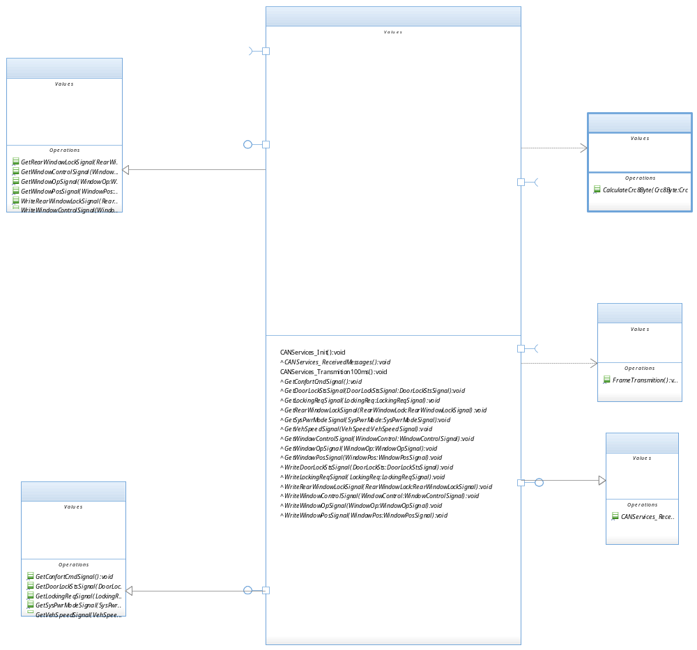

SW Component internal breakdown

Functional Decomposition
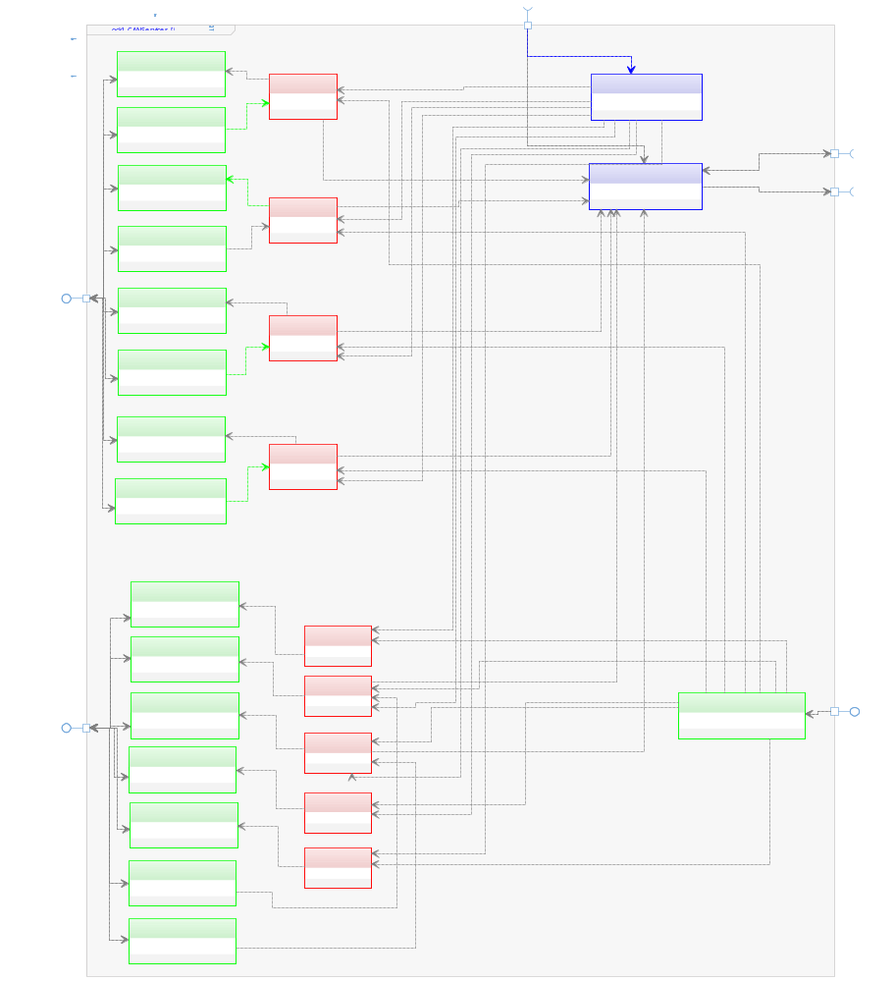

Function void CANServices_ReceivedMessages (struct CANFrame)

Description | This function is called by CANDriver to inform that a new CANFrame was received and it should be parsed to the corresponding engineering values.
Parameter 1  <input| output| inout> | Struct CANFrame <input>
Parameter 2..n | NA – Only use one parameter
Return Value | NA – Does not return a value.
Precondition | SWC shall be initialized first.
Post condition | All received values are updated. (SysPwrMode, ConfortCmd, VehSpeed, WindowPos, LockingReq, WindowOp, RearWindowLock, DoorLockSts, WindowControl)
Error Conditions | NA – Any error condition identified yet.
Requirements | NA – Review traceability matrix

Dynamic Behavior
Flow Chart¹
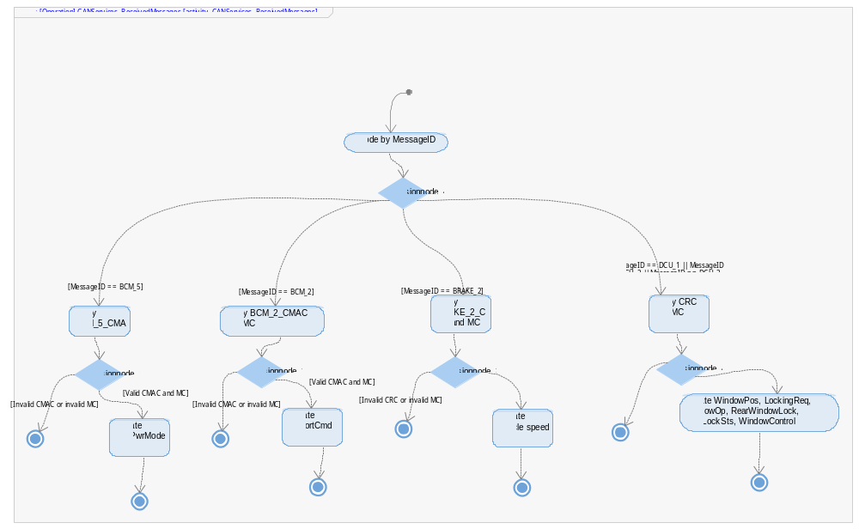

Function void CANServices_PeriodicTransmition (void)
Description | This function is call by OS 100 ms task to transmit the corresponding CAN frame.
Parameter 1  <input| output| inout> | NA – Does not use parameters.
Parameter 2..n | NA – Does not use parameters.
Return Value | NA – Does not return a value.
Precondition | SWC shall be initialized first.
Post condition | NA – Any post condition identified yet.
Error Conditions | NA – Any error condition identified yet.
Requirements | NA – Review traceability matrix

Dynamic Behavior
Flow chart:
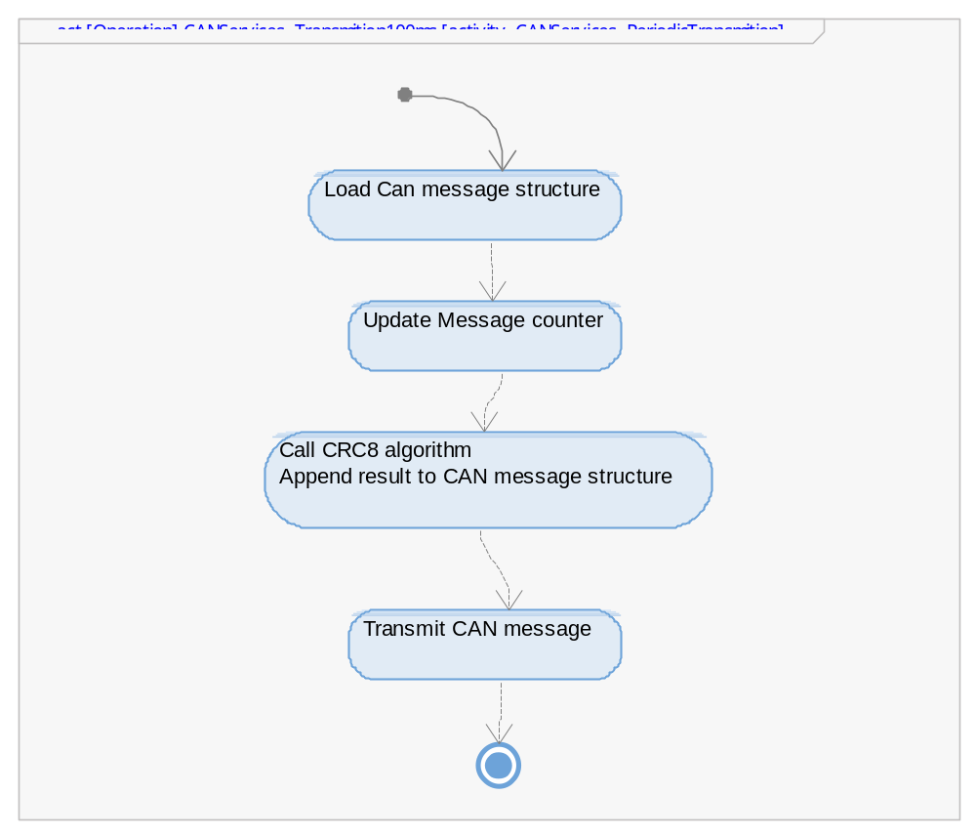

Function void CANServices_Init (void)
Description | This function is call by OS initialization task to set to default value all engineering variables (SysPwrMode, ConfortCmd, VehSpeed, WindowPos, LockingReq, WindowOp, RearWindowLock, DoorLockSts, WindowControl).
Parameter 1  <input| output| inout> | NA – Does not use parameters.
Parameter 2..n | NA – Does not use more parameters.
Return Value | NA – Does not return a value.
Precondition | OS shall have the correct set up.
Post condition | Engineering variables are updated. (SysPwrMode, ConfortCmd, VehSpeed, WindowPos, LockingReq, WindowOp, RearWindowLock, DoorLockSts, WindowControl)
Error Conditions | NA – Any error condition identified yet.
Requirements | NA – Review traceability matrix

Function void GetRearWindowLockSignal (RearWindowLockSignal* RearWindowLock)
Description | This function is call by WindowApp SWC to return RearWindowLock variable
Parameter 1  <input| output| inout> | RearWindowLockSignal* RearWindowLock <inout>
Parameter 2..n | NA – Does not use more parameters.
Return Value | NA – Does not return a value.
Precondition | SWC shall be initialized first.
Post condition | WindowApp receives the most recent and valid value for RearWindowLock variable
Error Conditions | NA – Any error condition identified yet.
Requirements | NA – Review traceability matrix

Function void WriteRearWindowLockSignal (RearWindowLockSignal RearWindowLock)
Description | This function is call by WindowApp SWC to update RearWindowLock variable
Parameter 1  <input| output| inout> | RearWindowLockSignal RearWindowLock <input>
Parameter 2..n | NA – Does not use more parameters.
Return Value | NA – Does not return a value.
Precondition | SWC shall be initialized first.
Post condition | CAN Services has the most recent value to transmit it by CAN Bus
Error Conditions | NA – Any error condition identified yet.
Requirements | NA – Review traceability matrix

Function void GetWindowControlSignal (WindowControlSignal* WindowControl)
Description | This function is call by WindowApp SWC to return WindowControl variable
Parameter 1  <input| output| inout> | WindowControlSignal* WindowControl <inout>
Parameter 2..n | NA – Does not use more parameters.
Return Value | NA – Does not return a value.
Precondition | SWC shall be initialized first.
Post condition | WindowApp receives the most recent and valid value for WindowControl variable
Error Conditions | NA – Any error condition identified yet.
Requirements | NA – Review traceability matrix

Function void WriteWindowControlSignal (WindowControlSignal WindowControl)
Description | This function is call by WindowApp SWC to update WindowControl variable
Parameter 1  <input| output| inout> | WindowControlSignal WindowControl <input>
Parameter 2..n | NA – Does not use more parameters.
Return Value | NA – Does not return a value.
Precondition | SWC shall be initialized first.
Post condition | CAN Services has the most recent value to transmit it by CAN Bus
Error Conditions | NA – Any error condition identified yet.
Requirements | NA – Review traceability matrix

Function void GetWindowOpSignal (WindowOpSignal* WindowOp)
Description | This function is call by WindowApp SWC to return WindowOp variable
Parameter 1  <input| output| inout> | WindowOpSignal* WindowOp <inout>
Parameter 2..n | NA – Does not use more parameters.
Return Value | NA – Does not return a value.
Precondition | SWC shall be initialized first.
Post condition | WindowApp receives the most recent and valid value for WindowOp variable
Error Conditions | NA – Any error condition identified yet.
Requirements | NA – Review traceability matrix

Function void WriteWindowOpSignal (WindowOpSignal WindowOp)
Description | This function is call by WindowApp SWC to update WindowControl variable
Parameter 1  <input| output| inout> | WindowControlSignal WindowControl <input>
Parameter 2..n | NA – Does not use more parameters.
Return Value | NA – Does not return a value.
Precondition | SWC shall be initialized first.
Post condition | CAN Services has the most recent value to transmit it by CAN Bus
Error Conditions | NA – Any error condition identified yet.
Requirements | NA – Review traceability matrix

Function void GetWindowPosSignal (WindowPosSignal* WindowPos)
Description | This function is call by WindowApp SWC to return WindowPos variable
Parameter 1  <input| output| inout> | WindowPosSignal* WindowPos <inout>
Parameter 2..n | NA – Does not use more parameters.
Return Value | NA – Does not return a value.
Precondition | SWC shall be initialized first.
Post condition | WindowApp receives the most recent and valid value for WindowPos variable
Error Conditions | NA – Any error condition identified yet.
Requirements | NA – Review traceability matrix

Function void WriteWindowPosSignal (WindowPosSignal WindowPos)
Description | This function is call by WindowApp SWC to update WindowPos variable
Parameter 1  <input| output| inout> | WindowPosSignal WindowControl <input>
Parameter 2..n | NA – Does not use more parameters.
Return Value | NA – Does not return a value.
Precondition | SWC shall be initialized first.
Post condition | CAN Services has the most recent value to transmit it by CAN Bus
Error Conditions | NA – Any error condition identified yet.
Requirements | NA – Review traceability matrix

Function void GetConfortCmdSignal (ConfortCmdSignal* ConfortCmd)
Description | This function is call by DoorLockingApp SWC to return ConfortCmd variable
Parameter 1  <input| output| inout> | ConfortCmdSignal* ConfortCmd <inout>
Parameter 2..n | NA – Does not use more parameters.
Return Value | NA – Does not return a value.
Precondition | SWC shall be initialized first.
Post condition | DoorLockingApp receives the most recent and valid value for ConfortCmd variable
Error Conditions | NA – Any error condition identified yet.
Requirements | NA – Review traceability matrix

Function void GetDoorLockStsSignal (DoorLockStsSignal* DoorLockSts)
Description | This function is call by DoorLockingApp SWC to return DoorLockSts variable
Parameter 1  <input| output| inout> | DoorLockStsSignal * DoorLockSts <inout>
Parameter 2..n | NA – Does not use more parameters.
Return Value | NA – Does not return a value.
Precondition | SWC shall be initialized first.
Post condition | DoorLockingApp receives the most recent and valid value for DoorLockSts variable
Error Conditions | NA – Any error condition identified yet.
Requirements | NA – Review traceability matrix

Function void GetLockingReqSignal (LockingReqSignal* LockingReq)
Description | This function is call by DoorLockingApp SWC to return LockingReq variable
Parameter 1  <input| output| inout> | LockingReqSignal * LockingReq <inout>
Parameter 2..n | NA – Does not use more parameters.
Return Value | NA – Does not return a value.
Precondition | SWC shall be initialized first.
Post condition | DoorLockingApp receives the most recent and valid value for LockingReq variable
Error Conditions | NA – Any error condition identified yet.
Requirements | NA – Review traceability matrix

Function void GetSysPwrModeSignal (SysPwrModeSignal* SysPwrMode)
Description | This function is call by DoorLockingApp SWC to return SysPwrMode variable
Parameter 1  <input| output| inout> | SysPwrModeSignal * SysPwrMode <inout>
Parameter 2..n | NA – Does not use more parameters.
Return Value | NA – Does not return a value.
Precondition | SWC shall be initialized first.
Post condition | DoorLockingApp receives the most recent and valid value for SysPwrMode variable
Error Conditions | NA – Any error condition identified yet.
Requirements | NA – Review traceability matrix

Function void GetVehSpeedSignal (GetVehSpeedSignal* VehSpeed)
Description | This function is call by DoorLockingApp SWC to return VehSpeed variable
Parameter 1  <input| output| inout> | VehSpeedSignal* VehSpeed <inout>
Parameter 2..n | NA – Does not use more parameters.
Return Value | NA – Does not return a value.
Precondition | SWC shall be initialized first.
Post condition | DoorLockingApp receives the most recent and valid value for VehSpeed variable
Error Conditions | NA – Any error condition identified yet.
Requirements | NA – Review traceability matrix

Function void WriteDoorLockStsSignal (DoorLockStsSignal LockStsSignal)
Description | This function is call by DoorLockingApp SWC to update LockStsSignal variable
Parameter 1  <input| output| inout> | DoorLockStsSignal DoorLockStsSignal <input>
Parameter 2..n | NA – Does not use more parameters.
Return Value | NA – Does not return a value.
Precondition | SWC shall be initialized first.
Post condition | CAN Services has the most recent value to transmit it by CAN Bus
Error Conditions | NA – Any error condition identified yet.
Requirements | NA – Review traceability matrix

Function void WriteLockingReqSignal (LockingReqSignal LockingReq)
Description | This function is call by DoorLockingApp SWC to update LockingReq variable
Parameter 1  <input| output| inout> | LockingReqSignal LockingReq <input>
Parameter 2..n | NA – Does not use more parameters.
Return Value | NA – Does not return a value.
Precondition | SWC shall be initialized first.
Post condition | CAN Services has the most recent value to transmit it by CAN Bus
Error Conditions | NA – Any error condition identified yet.
Requirements | NA – Review traceability matrix

